Three Steps Enabling You to Change and Improve Code

Software development process is like building a house; it requires great deal of effort to analyze, design, build, and maintain carefully going forward. However, there are significant differences between the two: 1. a house is not easy to change once it has been built but software is, 2. there is a high chance of risking lives by poor structure in house but it is low for the software. This is why a software developer has to be prepared for inevitable (or unavoidable) changes during the course of software life cycle. This series of articles introduces the industry recognized and systemic approach to make code changes easy, while reducing the risk of introducing bugs and improve the code while changing.

Step 1. Automated Unit Testing
Step 2. Refactoring
Step 3. Automated Building

Executive Summary
Automated unit testing gives developers fast and frequent feedback loop. Enough unit tests enable developers to prevent obvious bugs from being released (repeatedly), identify design problems earlier, have confidence on their codes, hence, change codes without worrying to break, and finally, improve quality of codes. NUnit framework and other related tools help developers record, maintain, and execute unit tests.
Introduction
Testing is essential when it comes to the software development. Otherwise, how do you know if it is going to work as intended when you put your code into the production environment? Because of this importance, most of development teams put many resources into this task. There are many kinds of testing (unit, component, integration, smoke, regression, load and stress testing, etc.) in various stages. Unit testing is a kind of software testing on the smallest compilable component, typically one programmer’s work [1]. This article is focusing on this unit testing, for which developer is solely responsible, and introduces an effective way of doing it.

Are you testing your code? If you do, are you still testing your code manually?
When it comes to a testing, developers are trying to avoid it, not because they do not want to but because they do not think they have time to. They do not think they have time since they are so busy developing new features and fixing bugs or do think that the testing is for someone else’s. It is easy to be said that anyone can do the testing but not everyone can do the developing. However, effective and efficient testing is hard to achieve. Developers often experience the embarrassment by introducing obvious bugs caught in the QA period or even in the production environment. As most of you already know, it is because manual testing is tedious, time consuming and error prone. Also, certain kinds of bugs tend to re-appear over a couple of releases because developers are fixing those bugs without recording the repeatable test for that fix going forward. These problems call for the systemic approach for the testing at the developer’s level!

Introducing Repeatable, Automated Unit Testing
Developers are already burdened by the given responsibility. If there is a tool to help this task they will appreciate and adopt this practice quickly. With this tool, developers have to be able to record, manage and execute list of tests, and analyze results easily. People in the software industry already figured this out and created unit testing framework called, JUnit for Java development community and there is a .NET port, NUnit. Recently, Microsoft also embraced this concept and incorporated its own unit testing framework into Visual Studio Team Edition for Software Developers. As a result, we do not need to re-invent the wheel, just need to utilize it. I will introduce this fantastic concept using NUnit framework and related tools. However, it is not difficult to apply this concept to other development environment.

NUnit Testing Framework
First thing that you have to do to get to know this framework is, download the software from this url, http://www.nunit.org and try it. After installation, you will get bunch of sample files and NUnit-Gui icon along with documentation. I will explain how to use it with slightly modified sample code. You can download source from here [http://account.zip – this will be a link to code zip file] and play with it by looking at the codes, compiling them, loading the output assembly onto NUnit-Gui (File->Open menu), and run the loaded tests (“Run” button). The sample has a class called, Account with Withdraw, Deposit and GetBalance interfaces, and corresponding unit tests. You will get below graphical UI indicating one of unit tests failed.

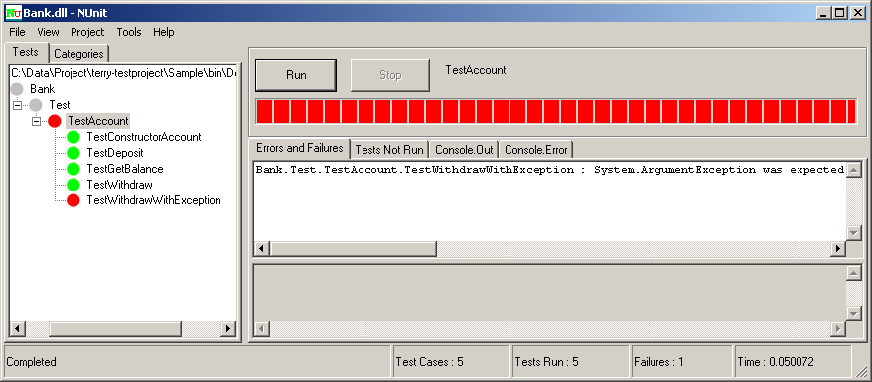

Every time you build the assembly, gui will refresh tests automatically.

Now let me explain how to write a unit test from the start. First, you have to reference the NUnit library, “nunit.framework.dll” and use its namespace and create a unit test fixture to house unit tests. NUnit detects any test(s) in an assembly by looking at .Net attributes using reflection. Therefore, you need to put attributes to your parts of the code. Here are frequently used attributes along with explanations.

NUnit Attribute | Explanation
TestFixture | Indicates that the class contains multiple related test cases.
SetUp | Indicates the method will be called before each test.
TearDown | Indicates the method will be called after each test.
Test | Indicates the actual test case to run.
Ignore | Indicates the test case should be ignored when running.

You are supposed to call static methods in the class, “Assert” to test a functionality of unit under test in each test case (code 1), or use the ExpectedException attribute to test if a method throws exception on exceptional condition (code 2).

[Test]
public void TestWithdraw() {
Assert.AreEqual(60, _unitUnderTest.Withdraw(60), "Withdraw method returned unexpected amount.");
}
Code 1

[Test]
[ExpectedException(typeof(ArgumentException))]
public void TestWithdrawWithException() {
_unitUnderTest.Withdraw(150);
}
Code 2

SetUp and TearDown are for isolating each test from affecting each other in a test fixture by running them before and after each and every test (code 3). Sometimes, it is critical to initialize things before you run a test case and clean up after when the unit under test has some global variables that could affect the test results across two or more tests.

[SetUp]
public void SetUp() {
_unitUnderTest = new Account(100);
}
[TearDown]
public void TearDown() {
_unitUnderTest = null;
}
Code 3

Once all the tests are ready, you can bring up the NUnit-Gui, load the generated assembly, and run tests. Gui will display the green or red bar depending on results of tests. It is pretty simple, isn’t it? The important point is that you put the adequate test codes in each unit test to cover all the aspects of logics under test. You will have a pretty good picture on how things are working once you get your hands dirty by running samples.

With this NUnit testing framework, you can run your suite of test cases across many assemblies with just one click and see the result right away with colorful and simple indicators, green, red or yellow reflecting success, fail or skip accordingly.

If you read NUnit documentation installed on your local hard drive you will know almost everything about this tool. However, I will explain a couple tips here to use this tool with Visual Studio to bootstrap you to get into the unit testing world.

[Tip 1] From NUnit version 2.2.2, the tool supports Visual Studio solution and project files. There are actually two versions of NUnit for different .net framework versions since formats of those files differ between versions. As a result, you can bring up the NUnit-Gui and run all the unit tests in a solution with just a menu click. Here is how you set it up on “External Tools” dialog box in Visual Studio 2005.

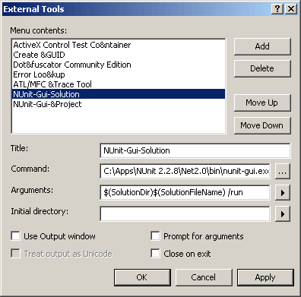

[Tip 2] You can also run all the unit tests in current project in the NUnit-Gui the same way.

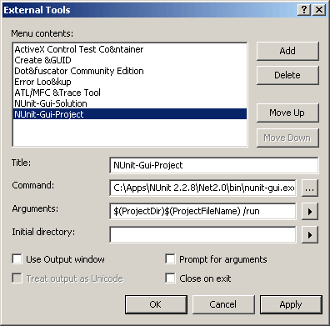

[Tip 3] Keyboard shortcut will save you the hassle of switching to mouse mode from keyboard mode.

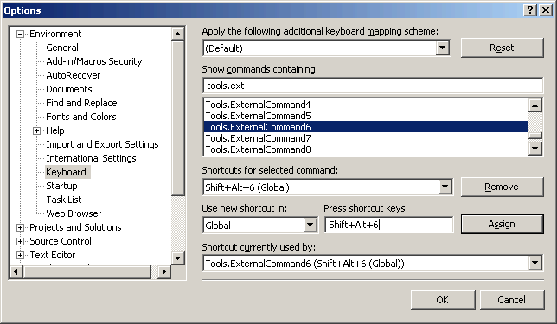

Of course, you can add NUnit-Console.exe in the same way too. In that case, you may want to check the “Use Output Window” option to get the test results inside the Visual Studio.
Here is the catch: you need to build first every time you want to execute these tests. However, this setup will save you money (since it’s free compared to other tools) and time to go outside from Visual Studio just to run the tests.

[Tip 4] You can attach Visual Studio debugger to gui to debug the test code or you can set the NUnit-Console to run in debug mode and put the result in the Debug output tool window if you can set the project’s property page as below screen shot.

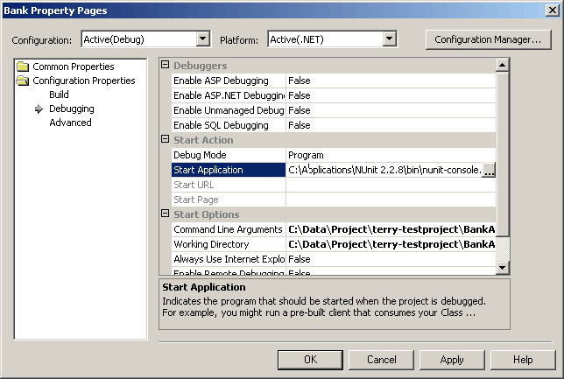

However, this setting is only valid if you are developing library project.

[Tip 5] Lastly, NUnit can accept configuration settings even if the unit under test is dll. Just put the “assembly_name.dll.config” in the appropriate directory where the output dll “assembly_name.dll” resides.

In addition to many features that this framework provides, there are a lot of tools developed around this framework to help developers even more.

NUnit related tools
Here are some tools that I have been using to make the unit testing easier.

- TestDriven.net: Visual Studio add-in that enables you to run tests inside Visual Studio with mouse click. Although results are being shown on the output window as text not graphic, this tool lets you debug unit tests in any project with, again, easy mouse click. - http://www.testdriven.net
- ReSharper 2.0: This is a famous refactoring tool from JetBrains. In version 2.0, they introduced NUnit interface to run tests inside Visual Studio and it gives you seamless experience just like NUnit-Gui. Also, it supports unit test debugging. - http://www.jetbrains.com
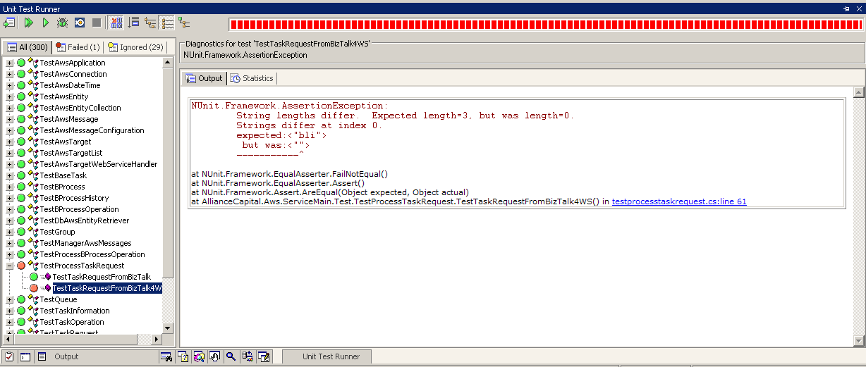

- NAnt: .Net port of the famous Java build tool, Ant. Open source folks built NUnit task called, “nunit2” for this build tool. As a result, incorporating unit testing into NAnt build process is a snap. Below is the nunit2 task script example to run unit tests in assemblies after the build. I will explain this tool in the last article of this series, “Step 3. Automated Building”. - http://nant.sourceforge.net

<nunit2 verbose="true">
<formatter type="Plain" />
<test assemblyname="output\Aws.Api.dll" />
<test assemblyname="output\Aws.AwsException.dll" />
<test assemblyname="output\Aws.Domain.dll" />
<test assemblyname="output\AwsSvc.exe" />
</nunit2>

- NUnitGenAddIn: This is a tool that I created to ease the developers’ pain of re-typing all the necessary plumbing codes to create unit tests for existing source code. It is a Visual Studio add-in, in other words, you can generate tests as you develop inside IDE. I created a manual explaining how you can use this tool and you can download it here, http://developer.novell.com/wiki/index.php/Special:Downloads/nunitgenaddin/NUnitGenAddIn-Manual-v0.1.1.doc. (Please send me any feedback to improve this tool :) - http://developer.novell.com/wiki/index.php/NUnitGenAddIn
- NUnitForms: NUnit extension for unit testing of Windows Forms applications. - http://nunitforms.sourceforge.net
- NUnitAsp: Another extension of NUnit for ASP.NET - http://nunitasp.sourceforge.net
- NCover: Code coverage analysis tool that gives you an idea of how thorough your tests cover your codes. - http://ncover.org

User Interface Testing
User interface is hard to do automated unit testing since running user interface requires heavy ground work and they change more often than the backend code, making maintenance a burden. This is the very reason that many advanced developers usually implement model-view-controller design pattern [Gamma et al., 1995] when it comes to user interface related development. You can create as many unit tests against model and controller of the system, while view contains the minimum logic. Microsoft’s Composite UI Application Block (CAB) was developed specifically this in mind, testability, utilizing this pattern. If you really need to test user interface, there are various unit testing frameworks available. NUnitForms and NUnitAsp are noticeable ones among others. I once used NUnitAsp for small part of bernstein.com development before and it is easy to use and works very well.

Mock Objects
Since you are doing unit testing not integration testing, any dependency of the unit under test should not change the test result. In other words, if the code that you are testing is dependent on other component, that is not easy to set up, and/or whose state is not consistent (i.e., changes unexpectedly), you need to fake or mock that component so that you can test the unit easily and consistently. This practice of creating mock objects and replace dependent components gives you a chance to use various object oriented design principles/patterns, including famous dependency injection pattern[2]. I personally have been using my own several implementations for mocking database since I have been dealing with a lot of database interactions for “Cda Library” and “Aws” projects. You can download actual codes that I wrote from here [http://MockDataReader.zip – this will be a link to code zip file] for mocking DataReader class. Again, please send me any feedback about this. This topic deserves a separate article. I hope I can re-visit this in the near future.

Rapid Feedback Loop
Just like the fast and frequent feedback from end user is important for the software development cycle, having feedbacks in each development step is invaluable for software developers. Rather than designing or implementing and then waiting weeks or months for someone else to feel the pain or glory, feedback comes in seconds from unit tests [Beck, 2002, p203]. Feedback is important for developers since they need to develop complicated model of unpredictable human process[3]. Creating unit tests is like being a middle/end user of your code. Therefore, you can even detect the design problem early enough to change it quickly without going through long usual feedback loop. Try it, you will love it!
TDD (Test-Driven Development)
I believe TDD could be a great methodology once you are disciplined to follow, since by adopting the unit testing, I personally have been seeing great results. However, it requires changing the habit, traditional programming style, to which most developers are accustomed for many years. Obviously, this changing one’s habit is functioning as high barrier to entry. In my humble opinion, developers need not spend a lot of energy to adopt it completely. Rather, accept the benefits of doing unit testing and keep creating them until you are comfortable with. Developers can get huge benefit just by creating the right amount of unit testing without sacrificing great deal of efforts. I take pleasure of starting codes to make something quickly and create tests around it whenever I need to change that code but, before making those changes. Try applying this to legacy codes that you have to change! Lastly, you need to maintain unit tests that you created; otherwise, it will be useless after some changes. However, TDD incorporates this into the disciplined, test first coding practice, eliminating the idea of maintaining unit tests.

Gain Confidence in Your Code
Main benefit of adopting unit testing is just like Kent Beck puts on TDD, “It enables you to gain confidence in the code over time. As tests accumulate, you gain confidence in the behavior of the system.” [Beck, 2002, p201] When you do not have confidence on your code you tend to avoid the changes. Developers cannot write beautiful codes from the start unless they are high skilled. Therefore, changing code is obvious steps to follow once you write codes, to make a piece of software better over time. By creating enough unit tests to cover critical points, developers become confident enough to change their codes willingly to adapt changing requirement. The more changes developers make, the better the quality of software becomes.

Even Better in Team Development Environment
Unit testing could save unexpected bug in the team development environment. When multiple developers are working on a same project, code change in one place could affect other unexpected places. Since components are usually dependent on other components, unit tests in other components could detect the change in one component wrong right away, without going through long integration testing stage. I have experienced this couple of times in cda library project :) Also, unit tests are like “living documents” helping other team members change any codes in the project since they can see right away if the changes that they made are breaking any existing logic and correct them if any, by simply running them and inspecting failed tests.

Broken Test
Ever experienced a long recovery time when you had a long break from programming? Kent Beck introduced a “Broken Test” concept [Beck, 2002, p.148] and it is a great practice for me to continue working instantly after a long break. The trick is, make a test broken what you need to continue working on later, before you leave the programming session. When you come back to the code, you then have an obvious place to start.

Things to Remember and The Next Step
Here are some points that you should remember.
  - Test the state of an instance of a class by calling its interfaces and/or output of a function by providing various inputs.
  - Replace other complicated and heavy components with mock objects.
  - Write as many tests as possible to cover most of functionalities of your code.
  - Maintain them going forward, especially tests for bug fixes.
  - Finally, execute them and get fast feedback frequently.

You will see benefits of unit testing instantly, even with just a couple of unit tests. The important thing is, keep testing them whenever you change the code. Once you are comfortable with creating unit tests and changing codes, next obvious step is, changing codes in the right way. Combining unit testing with Refactoring will give developers chance to acquire sustainable coding and design skills. I will talk about the Refactoring, a great technique for changing existing code, in the next article of the series.

Reference
[1] http://www.faqs.org/faqs/software-eng/testing-faq/section-14.html
[2] http://www.martinfowler.com/articles/injection.html
[3] http://www.martinfowler.com/articles/newMethodology.html
[Beck, 2002] Test Driven Development: By Example - Kent Beck - 2002
[Gamma et al., 1995] Design Patterns: Elements of Reusable Object-Oriented Software - Erich Gamma, Richard Helm, Ralph Johnson, John Vlissides - 1995

